Question 4
- Create a rule that automatically assign a bug to a developer when the priority set to highest

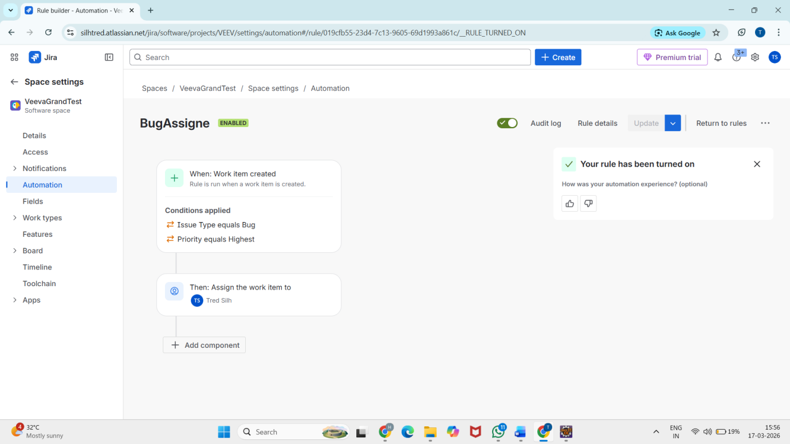
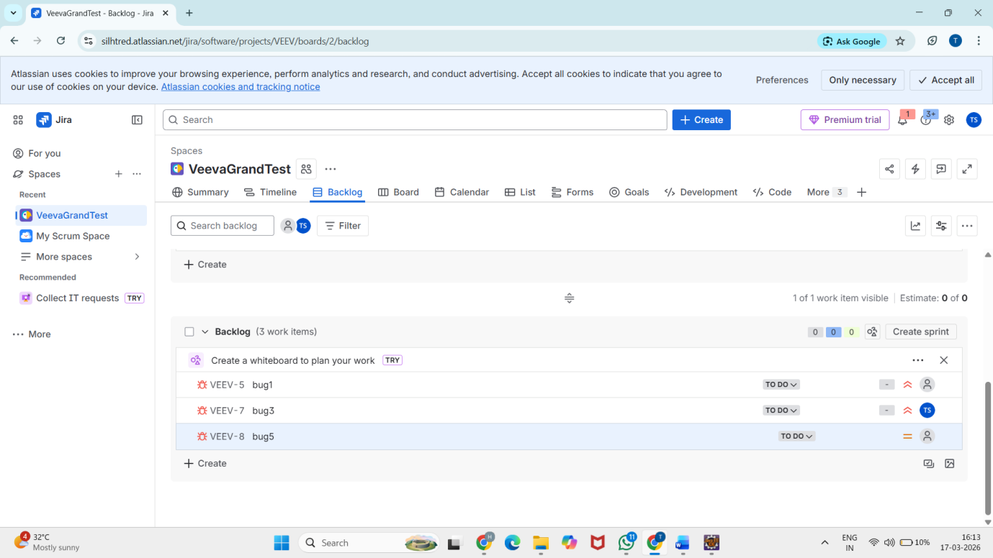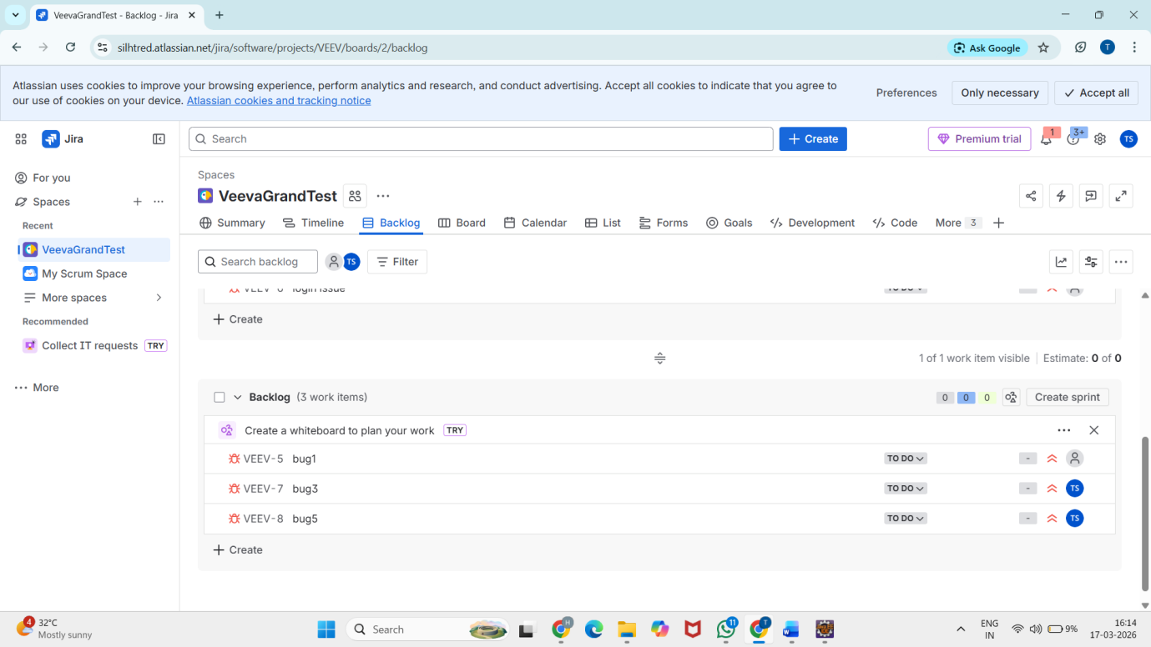

- Write a query to find all unresolved bugs in a specific project assign to a specific user . Example->project=P1 and issuetype=bug and status!=done and assignee=current user

